Player Questionnaire. | 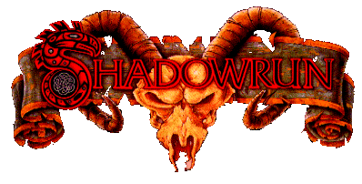

- What part of Shadowrun do you find the most fun and would like to see more of in your games, rate each one from one to three:

  - Combat ____
  - Matrix (Decking etc.) ____
  - Magic ____
  - Vehicle combat (Rigging) ____
  - Covert operations and infiltration (Sneaking around facilities undetected) ____

- Of what importance would you rate the following to your enjoyment of a Shadowrun game? Rate each from one to ten:

  - Corporate intrigue ____
  - Character development and history ____
  - World politics ____
  - Learning new things about the sixth world ____
  - Interacting with NPC’s (Non Player Characters) ____
  - Interacting with PC’s (other Player Characters) ____

- What importance do you attach to your characters background, emotions and reasons for doing things? (Rate One to Ten) ____

- What level of realism do you expect from a Shadowrun game? (Circle one option)

  - Very realistic, taxes, work, laws, diseases, weapon failures, bad luck and anything else that happens in your own day-to-day life.
  - Average realism, important stuff matters, but we can skip the boring day-to-day drek such as shopping for groceries and feeding the dog.
  - Unrealistic, you never have to bother about cleaning those guns, ammo materialises out of no-where and you can open up on full-auto at anyone in the street that you don’t like with the minimum of consequences.
  - Highly Unrealistic If I want to walk around with a forehead mounted Mr. Studd implant and a fully automatic railgun over my shoulder while walking next to my pet corporate dragon, then no-one should find this strange and even pass another look at me in the street.

- How often would you like to play Shadowrun with it still being fun and not consider yourself a total looser?
  - Twice a week
  - Once a week
  - Once every two weeks
  - Once a month
  - Only when I can’t possibly talk my boyfriend/girlfriend out of going, and the only other thing happening that night is the annual grass growers prize giving.

Your character
- How important do you feel that your characters background, life story and relatives are? Rate from one to 10. _______

- What do you like the most about your character?

- Are there any specific things you would like to see happen to your character? e.g. Get married, find a long lost brother, lose a limb etc.

